Art 3200
Paper Mache Sculpture
You will create a larger than life sculpture that is based on a visual pun or play on words and is inspired by the Pop Art Movement.

OBJECTIVES:
- Interpret a phrase or word in 3-D making a visual pun - play on words.
- Create an armature and construct paper maché sculpture
- Exhibit craftsmanship in papier maché and painting
- Learn about Pop Art Movement.

MATERIALS:
- Paper mache (flour, water, and salt)
- Newspaper and white paper (white paper will be used for the last layer of paper mache)
- Masking tape
- Cardboard, wire, and other objects that can be used to build the armature.
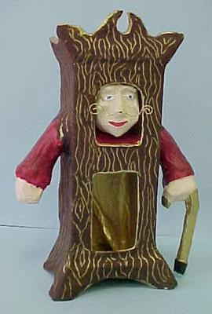
- Liquid tempera and acrylic paint

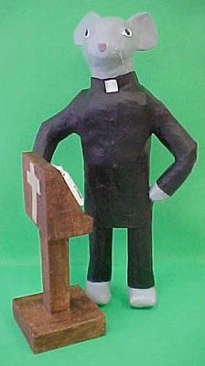
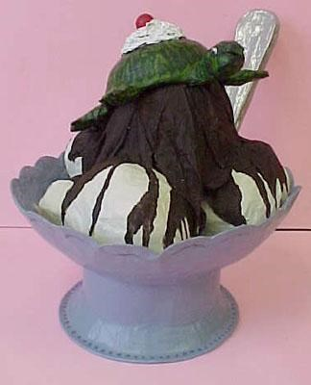

REQUIREMENTS:
- Minimum is larger than life size and no smaller than 10in x 10in x 10in any direction.
- Maximum size is questionable.
- Added Material - Add something interesting to your piece to make it stand out!
- You must be able to finish your end product in an accomplished, expressive, and neatly executed manner.

SUBJECT:
A visual pun or play on words. For example: butterfly (butter with wings)

Your final product may be:

- Humorous

- Allegorical (a symbolic representation, a pictorial device in which objects stand for abstract ideas, principles, or forces, so that the literal sense has or suggests a parallel, deeper meaning)

- Metaphorical (one thing conceived as representing another; a symbol, a figure of speech in which a word or phrase that ordinarily designates one thing is used to designate another, thus making an implicit comparison, as in "a sea of troubles")

- A visual oxymoron (A pictorial contradiction-a lead balloon, clear as mud)

- Self-Contradictory

- A Parody (artistic work that imitates the style of an author or a work for comic effect or ridicule, intentional mockery)

PROCEDURES:

- Construct armature with cardboard, wire, wire screening - secure with masking tape. Aluminum foil can be added for details and for smoothing over surface.

- Apply at least two layers of newspaper paper maché - final layer can be white newsprint to make painting easier.

- Allow to dry - paint with acrylics and liquid tempera.

- Add details and accessories.

ASSIGNMENTS/PROJECT PREP/QUESTIONS:
To be completed BEFORE creating sculpture:
- Brainstorm and list 12 ideas that could be used as a visual pun.
1 - ________________________________________________________________________
2 - ________________________________________________________________________
3 - ________________________________________________________________________
4 - ________________________________________________________________________
5 - ________________________________________________________________________
6 - ________________________________________________________________________

7 - ________________________________________________________________________

8 - ________________________________________________________________________

9 - ________________________________________________________________________

10 - ________________________________________________________________________

11 - ________________________________________________________________________

12 - ________________________________________________________________________
- Take 3 of these ideas of what you might do for your assignment and create a thumb nail sketch of each.

- Take the design that works best and elaborate on it. Draw it to exact proportion with detail included.

- List materials that you will need to complete your sculpture

To be completed AFTER creating sculpture:
- What type of sculpture are you creating?
_______________________________________________________________________________
_______________________________________________________________________________
_______________________________________________________________________________
_______________________________________________________________________________
_______________________________________________________________________________
_______________________________________________________________________________

- Is your sculpture humorous, an oxymoron, etc.?
_______________________________________________________________________________
_______________________________________________________________________________
_______________________________________________________________________________
_______________________________________________________________________________
_______________________________________________________________________________
_______________________________________________________________________________
- How did you build your armature?
_______________________________________________________________________________
_______________________________________________________________________________
_______________________________________________________________________________
_______________________________________________________________________________
_______________________________________________________________________________
_______________________________________________________________________________

- What did you learn about paper mache sculptures while doing this project?
_______________________________________________________________________________
_______________________________________________________________________________
_______________________________________________________________________________
_______________________________________________________________________________
_______________________________________________________________________________
_______________________________________________________________________________

Visual Pun Sculpture (Paper Mache)

Followed Instructions (Pre-Sculpture Prep)  - Brainstorm and list 12 ideas that could be used as a visual pun. | 12 | 11 |  | 10 |  |  |  | 9 |  |  | 8 |  |  |  | 7 |  |  | 6 |  | 5 |  |  |  | 4 |  |  |  | 3 |  |  |  | 2 |  |  | 1 |  | 0
- Create a thumbnail sketch of 3 ideas. | 3 |  |  |  |  |  |  |  | 2 |  |  |  |  |  |  |  |  |  | 1 |  |  |  |  |  |  |  |  |  |  | 0
- Drew a complete sketch of final project with details. | 4 |  |  |  |  | 3 |  |  |  |  |  |  |  |  |  | 2 |  |  |  |  |  |  | 1 |  |  |  |  |  |  |  |  |  | 0
- Completed a materials list. | 4 |  |  |  |  | 3 |  |  |  |  |  |  |  |  |  | 2 |  |  |  |  |  |  | 1 |  |  |  |  |  |  |  |  |  | 0
Followed Instructions (Sculpture)  - Constructed armature with cardboard, wire, etc. | 4 |  |  |  |  | 3 |  |  |  |  |  |  |  |  |  | 2 |  |  |  |  |  |  | 1 |  |  |  |  |  |  |  |  |  | 0
- Applied at least two layers of newspaper paper mache. | 4 |  |  |  |  | 3 |  |  |  |  |  |  |  |  |  | 2 |  |  |  |  |  |  | 1 |  |  |  |  |  |  |  |  |  | 0
- Applied 1 layer of white paper/newsprint as the final paper mache layer. | 2 |  |  |  |  |  |  |  |  |  |  |  | 1 |  |  |  |  |  |  |  |  |  |  |  |  |  | 0
- Painted sculpture | 2 |  |  |  |  |  |  |  |  |  |  |  | 1 |  |  |  |  |  |  |  |  |  |  |  |  |  | 0
- Added details and embellishments. | 2 |  |  |  |  |  |  |  |  |  |  |  | 1 |  |  |  |  |  |  |  |  |  |  |  |  |  | 0
Effort/Level of Completion  - How much time was spent on the work?  - Was class time used wisely?  - Does the sculpture look finished or rushed? | 10 |  | 9 |  | 8 |  |  |  |  | 7 |  |  |  | 6 |  |  | 5 |  |  |  | 4 |  |  |  | 3 |  |  |  | 2 |  |  |  |  | 1 |  | 0
Overall Neatness  - Was care taken to make sure the project was neat and clean?  - Was the project treated with respect and handled gently (project should be put away properly after each class so that it is safe)?  - Was care taken to make sure there were no smudges or spills (paint)?  - Was care taken to make sure there are no dents or scratches (sculpture)? | 10 |  | 9 |  | 8 |  |  |  |  | 7 |  |  |  | 6 |  |  | 5 |  |  |  | 4 |  |  |  | 3 |  |  |  | 2 |  |  |  |  | 1 |  | 0
Quality of Paper Mache Sculpture  - Is the object easily recognizable as a visual pun?  - Is the sculpture freestanding?  - Is the sculpture strong and durable (it should not be weak or flimsy)?  - Is the paper mache applied evenly? | 10 |  | 9 |  | 8 |  |  |  |  | 7 |  |  |  | 6 |  |  | 5 |  |  |  | 4 |  |  |  | 3 |  |  |  | 2 |  |  |  |  | 1 |  | 0
Quality of Painting and Added Details on Sculpture  - Does the paint cover all areas?  - Is the paint applied evenly?  - Is the paint mixed well?  - Are added embellishments attached well? | 10 |  | 9 |  | 8 |  |  |  |  | 7 |  |  |  | 6 |  |  | 5 |  |  |  | 4 |  |  |  | 3 |  |  |  | 2 |  |  |  |  | 1 |  | 0
Creativity  - How much thought was put into the sculpture design and theme?  - Is the sculpture an original idea or copied?  - Is sculpture design different from other classmates’ designs (or your own past work)?  - Was there effort to add detail to the sculpture? | 10 |  | 9 |  | 8 |  |  |  |  | 7 |  |  |  | 6 |  |  | 5 |  |  |  | 4 |  |  |  | 3 |  |  |  | 2 |  |  |  |  | 1 |  | 0
Followed Instructions (Post Sculpture Review)  - What type of sculpture did you create? | 2 |  |  |  |  |  |  |  |  |  |  | 1 |  |  |  |  |  |  |  |  |  |  |  |  |  | 0
- Is you sculpture humorous, an oxymoron, etc.? | 2 |  |  |  |  |  |  |  |  |  |  | 1 |  |  |  |  |  |  |  |  |  |  |  |  |  | 0
- How did you build your armature? | 4 |  |  |  |  |  | 3 |  |  |  |  |  |  |  | 2 |  |  |  |  |  |  | 1 |  |  |  |  |  |  |  |  | 0
- What did you learn about paper mache sculptures while building this project? | 4 |  |  |  |  |  | 3 |  |  |  |  |  |  |  | 2 |  |  |  |  |  |  | 1 |  |  |  |  |  |  |  |  | 0
TOTAL (of possible 100)

