Art 2200
Silhouette Painting
You will create a beautiful silhouette painting using acrylic paints.
A silhouette is a dark shape and outline of someone or something visible against a lighter background, especially in dim light. A silhouette can also refer to a dark shape and outline against a lighter background.
Your painting will have a black silhouetted image on a colourful background.
For your painting, you will need to plan the image that you would like to silhouette before you create the background. Your silhouette has to be a personal object, or a symbol/image of something that is personal to you. You will draw your object, symbol, or image within a landscape. You will then choose your background colours carefully so that the atmosphere created by the colours will match the emotion or theme that you are trying to show in your image.
Silhouette painting process:
- Sketch and plan your painting in your folder
- Paint the background of your canvas board. Make sure that the canvas and edges are completely covered.
- Create a template of your silhouette. Draw your silhouette carefully to scale on card stock (we will use recycled file folders for this). Carefully cut out your silhouette.
- Trace your silhouette template onto your background with pencil.
- Fill in your silhouette with black paint. Make sure to apply paint carefully and neatly, covering all areas.
- You may decide to add details after the silhouette is filled in with black, but it is not required.

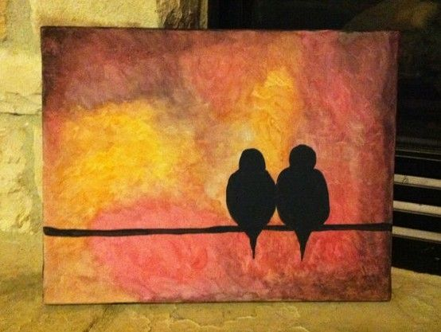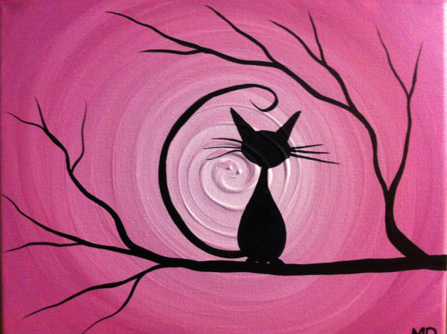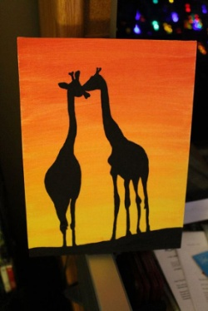
SILHOUETTE PAINTING

Followed Instructions  Included all requirements including:  - Sketched and planned your painting in your folder (2 marks)  - Painted the background of your canvas board (using multiple layers of paint). (2 marks)  - Make sure that the canvas and edges are completely covered. (1 marks)  - Created a template of your silhouette. Draw your silhouette carefully to scale on paper or cardstock. (1 mark)  - Carefully cut out your silhouette. (1 mark)  - Traced your silhouette template onto your background with pencil. (1 mark)  - Filled in your silhouette with black paint. (2 marks) | /10 points
Effort/Neatness  - Was class time used wisely?  - Was the project submitted on time?  - Was care taken to make sure the project was neat?  - Was the project treated with respect and handled gently (project should be put away properly after each class so that it is safe)? | / 8 points
Quality of Background Painting  - Is the canvas completely covered (there should be no white canvas showing)?  - Are the colours clearly blended?  - Does the background colour scheme relate to the silhouette?  - Are the edges completely painted? | / 8 points
Quality of Silhouette Painting  - Is the silhouette outline painted neatly?  - Is the silhouette filled in neatly?  - Is the silhouette paint applied evenly?  - Are the pencil lines erased cleanly? | / 8 points
Creativity  - How much thought was put into the choice of the design?  - Did you choose an interesting design that was different from others' designs?  - Did you choose a design that was simple or challenging?  - Did you draw the design yourself or copy it from the internet/book/etc.? | / 8 points
Review Questions  - What object/symbol did you choose for your silhouette?  (2 marks)  - Why did you choose this image? (3 marks)  - How does your background colours relate to your choice of silhouette? (3 marks) | / 8 points
TOTAL (of possible 50) | / 100 =

