Optical Illusion Sketchbook Project
Art 1201
Before beginning our final optical illusion project, we need to practice drawing optical illusions so we will have a better understanding of how to construct them. Complete each of the following optical illusions on a full sheet of paper. Remember to be neat, draw crisp lines and shapes with clean edges, and don't colour outside the lines.

Optical Illusion Practice Sketch #1 - Sections and Shapes
- Put a point in the middle of your page.
- Draw straight lines through this point, then draw a series of shapes all over the page. Make sure you don't overlap your shapes.
- Now you're ready for shading. You will shade only one section at a time. Alternate between black and white (or two complementary colours). Continue alternating between shading the shape and the space around the shape until you have shading in every section.

Note: This optical illusion alternates between black and white lines/shapes. Objects should get smaller the closer they get to the center.

Optical Illusion Practice Sketch #2 – Sliding Bricks
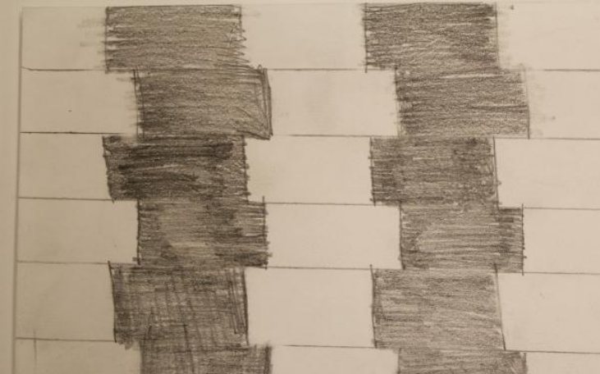
- Using a ruler, draw 5 or 6 horizontal lines across your page.
- In the bottom space, divide it using 4 or 5 vertical lines and shade every second space (like you would do if you were drawing bricks).
- In the next space above, draw your vertical lines slightly to the right of the ones you drew underneath. Shade the spaces above the ones you shaded in the first row.
- For your third row up, draw vertical lines in the same places as you did in the first row. Shade in your spaces.
- Repeat this pattern all the way to the top.

Note: This optical illusion slightly moves the edges of shapes so they don't perfectly line up which will create movement.

Optical Illusion Practice Sketch #3 – Thick and Thin Columns
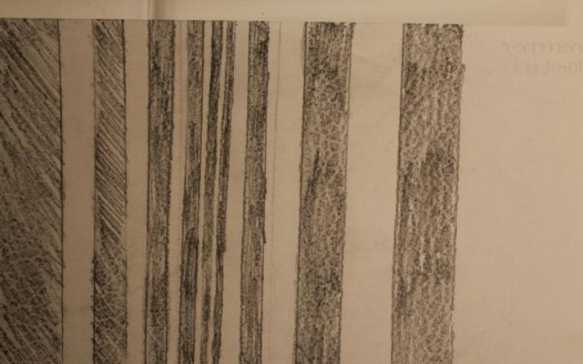
- On the left of your page, draw a wide column and fill it with shading.
- Leave a space, then draw another column that's slightly thinner than the first.
- Leave a slightly smaller space, then draw a slightly thinner column than the one you just drew.
- Keep following this pattern until your column is so thin that it's just a single pencil line.
- Then start getting gradually thicker again with your columns and spaces between.

Note: This optical illusion changes the width of lines to create depth.

Optical Illusion Practice Sketch #4 – Donut
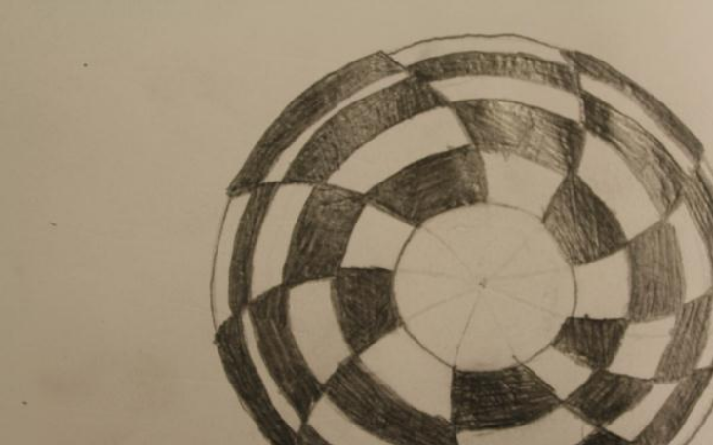
- Using a compass, draw a small circle in the center of your page.
- Using the same center point, draw a circle that is only slightly larger than the first.
- Draw 5 or 6 more circles, each one getting slightly wider.
- Then start drawing circles that become closer to the previous ones you drew.
- Draw a curved line from the center of the circle to the edge.
- Draw 7 more lines like this, each one curved in the same direction and breaking the circle into equal pieces.
- Erase the center circle.
- Shade every second shape in the inner ring.
- Alternate your shading in the next ring, making sure that you don't have two dark or white areas touching.
- Repeat this shading pattern until you have your entire wheel shaded.

Note: In this optical illusion you will make something look round by drawing circles close together using the same central point, then increase the width between them, then decrease it.

Optical Illusion Practice Sketch #5 – Concentric Circle
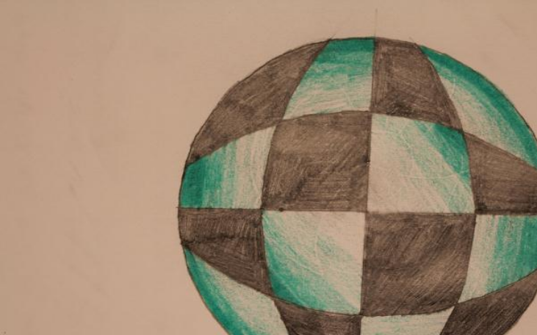
- Draw a large circle in the center of your page.
- Using a ruler, divide your circle in half. Place a protractor on the center of this line to find the 90 degree mark. Draw a straight line through the center of your circle and this 90 degree mark. Your circle should now be divided into quadrants.
- Place the sharp end of your compass at one point where one of your lines touches the outside of your circle. Open your compass until the pencil lands just over 3/4 of the diameter of the circle. Draw an arc from one side of the circle to the other.
- Making sure your compass stays the same width, move the sharp end to another point on the outside of the circle. Draw another arc on the opposite side, again just over 3/4 of the way across the circle.
- Do this two more times, drawing two more arcs.
- Shade in every second space in your circle.
- Using a colouring lead, shade in every white space going from dark on the outside of the circle to light towards the center. In the large two white spaces in the center, go from dark in the outside corners to light towards the center.

Note: In this optical illusion, you will create the illusion of depth by shading from dark to light. Be neat; draw crisp lines and shapes with clean edges. Don't colour outside the lines

