Art 1201
Haunted Scenes
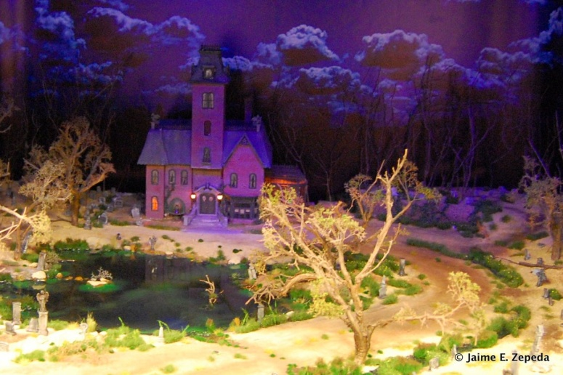
For this project, you will get in groups of 2 or 3 to construct a haunted house/scene (you can also work on your own if you wish).
You will need:
• Cardboard, construction paper, tape, scissors
• Paint
• Glue sticks and hot glue guns
• Utility knives and blue cutting mats
• A variety of Halloween items (bugs, bats, spiders, webs, etc.)
The goal of this project is to be as creative and unique as possible. Think of ways to make your scene EXTRA SPOOOOOKY!
Here is how you will be evaluated by your peers:
Halloween Scene | Excellent  4 | Very Good  3 | Average  2 | Needs Improvement  1 | Incomplete  0
- Followed Instructions (Designed haunted house with your group, covered outside of box, decorated inside of box, added details)
- Effort/Neatness (How much time was spent on the work? Was class time used wisely? Was care taken to make sure the project was neat? Was the project treated with respect and handled gently?)
- Level of Completion (Does the Halloween scene look finished or rushed? )
- Quality of Halloween Scene (Did you pay attention to detail while constructing the scene, characters, props, etc.?
- Creativity (Overall creativity with use of characters, props, background, etc.)
Total Marks (out of 20)

