Christmas Tree Challenge
Art 1201
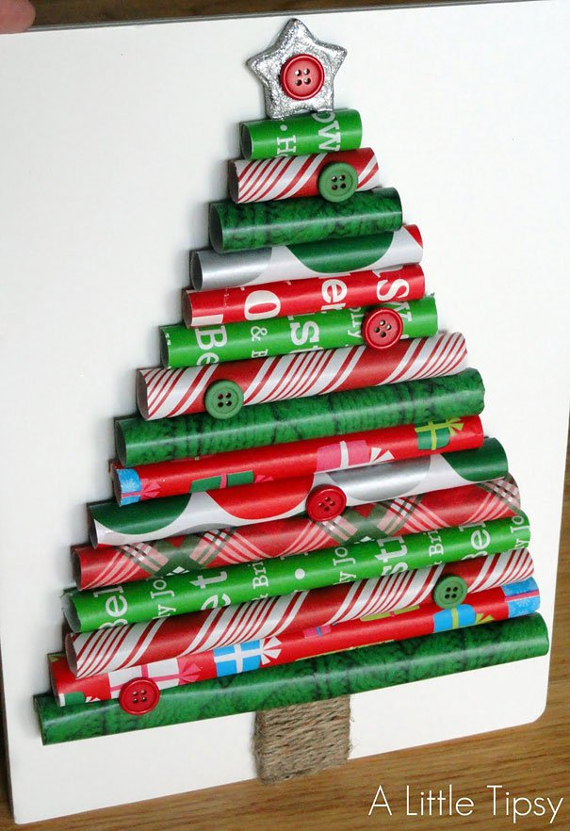
For this project, you will get in groups of 2 or 3 to construct a Christmas tree (you can also work on your own if you wish).
Christmas Tree requirements:
• Tree must be a minimum of 18 inches high
• Tree must be a sculpture in-the-round which is freestanding
• Tree must be colourful, bright, and cheerful
• Tree must be constructed with recycled materials (although decorations/accessories may be added)
The goal of this project is to be as creative and unique as possible. Think of ways to make your tree bring cheer and Christmas spirit to others. :)
Here is how you will be evaluated by your peers:
Christmas Tree | Excellent  4 | Very Good  3 | Average  2 | Needs Improvement  1 | Incomplete  0
- Followed Instructions (Designed Christmas tree with your group, created Christmas tree shape, decorated tree, added details)
- Effort/Neatness (How much time was spent on the work? Was class time used wisely? Was the project passed in on time?)
- Neatness (Does the Christmas tree look finished or rushed? Was care taken to make sure the project was neat? Was the project treated with respect and handled gently?)
- Quality of Christmas Tree (Did you pay attention to detail while constructing tree trunk, branches, decorative details, etc.?
- Creativity (Overall creativity with use of materials, colours, accessories, etc. Was the tree an original idea or copied? Is the tree different or similar from your classmates' trees?)
Total Marks (out of 20)

